SEND COMMANDS TO ASHTECH RECEIVER

Here under, user will find short explanation on how to send commands to PM100/PM200/PM800/PF800 and how to record the responses from the receiver.
Some commands will induce long response from receiver and it may be not convenient just to display the response. So user must record these responses in a TXT file to allow it to be viewed later.

In the following example, we will use software called WinCom which is a tool available through the GNSS Solutions software package. It is also available on our FTP site here:
ftp://ftp.ashtech.com/Utility%20Software/WinComm/V7.10_eng.zip

Any other communication software can be used (hyperterminal, AshCom, …)
In the case of WinXP, Hyperterminal is part of the package. In Win7, this software is not anymore provided. So user must use other communication software.

Open WinCom
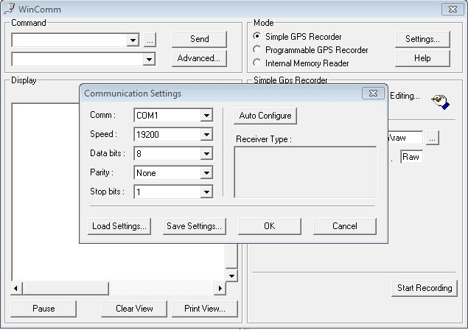
Select the right PC COM port and the correct speed.
Ashtech receivers works at 19200 bauds by default.
Select directory where you will record the TXT file containing the responses to the commands:
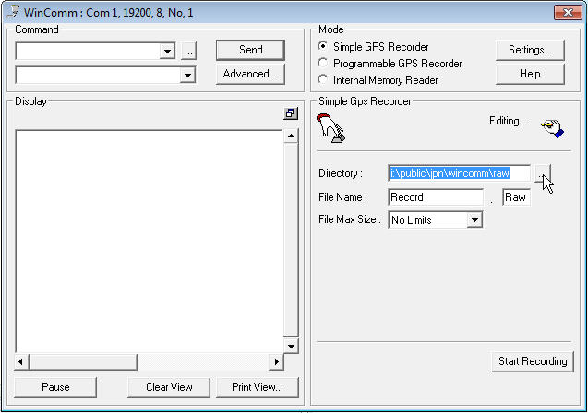

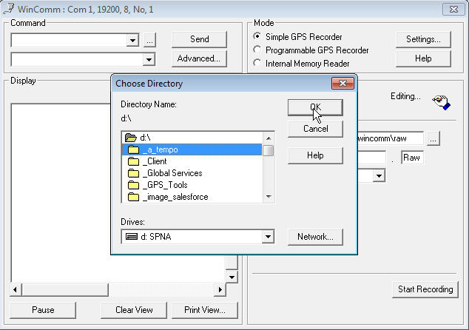

Name TXT file name; don’t forget to set extension file to TXT
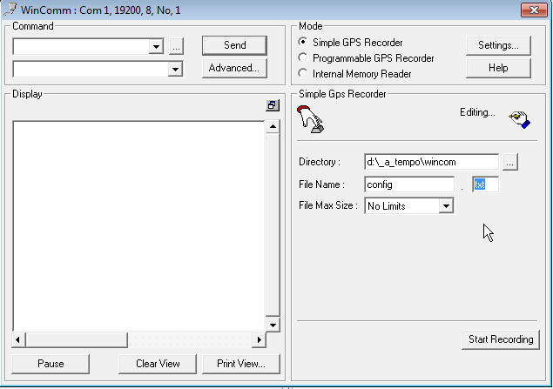

Then click on “Start Recording”
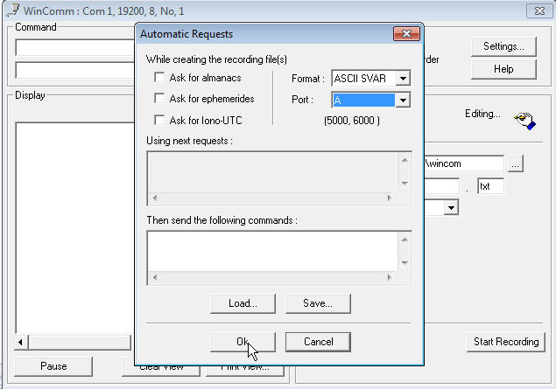
Uncheck the 3 boxes on the left “Ask for…”
Leave Format and Port parameter as they are
Click on OK button; check that icon changes from 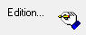 to 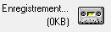
at that time, all responses from receiver will recorded in the TXT file you created.

Send commands
Commands must be enter in the Command box.

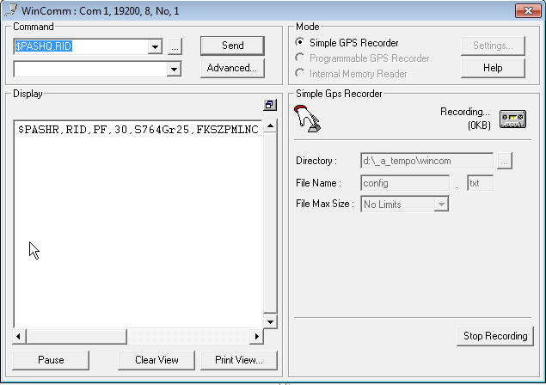

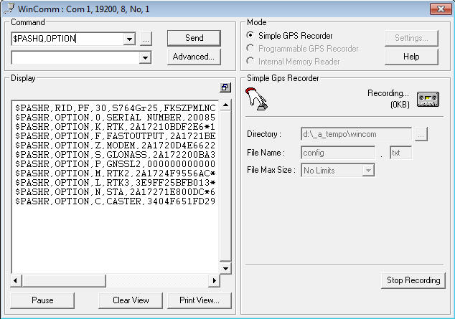
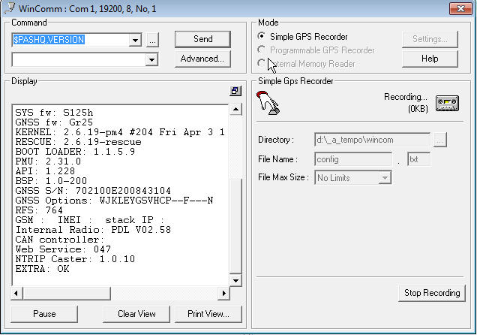

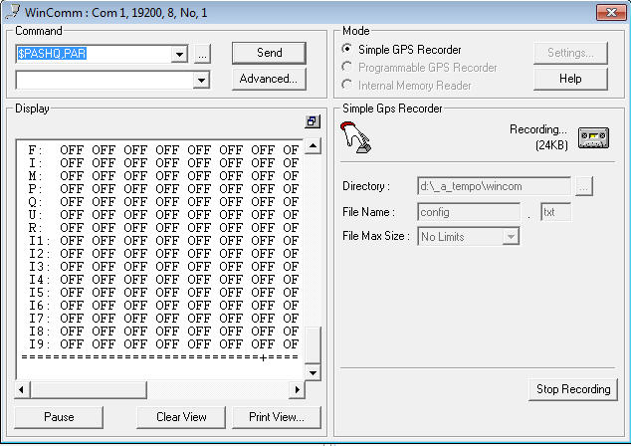
Click on “Stop Recording” button

Recording a Configuration setup file (PM800/PF800)
User has now the possibility to record all configuration setup in a file. He will then be able to configure others receivers with the same configuration using that file.
To save the configuration, user must connect a USB memory key to PM800/PF800
Then he will have to send the command:
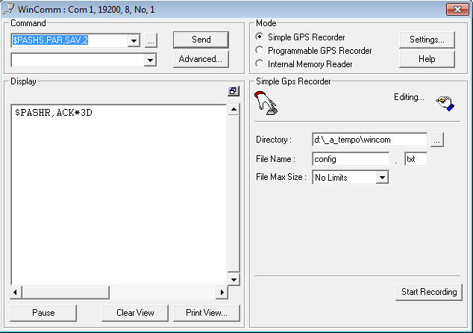
When checking the USB key on Windows Explorer, user will find a file named like this
PF_sssss_dddhhmmss.par where
PF means ProFlex800 (PM in the case of ProMark800)
sssss means last 5 digits from serial number
ddd means Julian day of the year
hh means hours
mm means minutes
ss means secondes
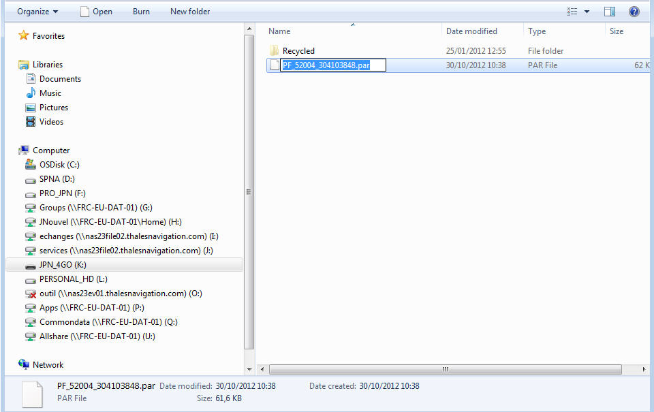
This file can then be introduced into another receiver:
Connect USB key containing the PAR file to the receiver
Send the command $PASHS,PAR,LOD,2,file_name.PAR
And receiver will get the configuration.

